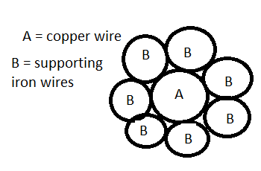 $R_{T} = \frac{1}{\frac{1}{\frac{R_{B}}{7}}+\frac{1}{R_{A}}}$

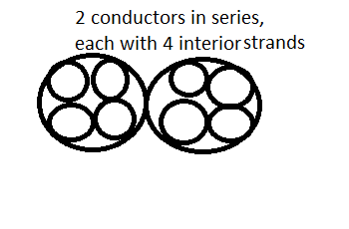

$R = \frac{2ρl}{4πr^{2}}$

Where 2 is the number of conductors in series, 4l is the length of each conductor, 4 is the number of strands in each conductor and r is the radius of one of the strands

From spec:

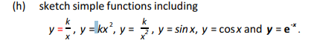

Be careful with questions with mass in g or cm etc, remember to convert to correct units

AS Equations that could come up again:

$$λ = \frac{h}{ρ} = \frac{h}{mv}$$

TODO: add AS equations